PICTURES TAKEN AT THE JIV TO NAOC, OBIAFU 26S FLOW LINE, OBIAKU FIELD, OMOKU, ONELGA, RIVERS STATE

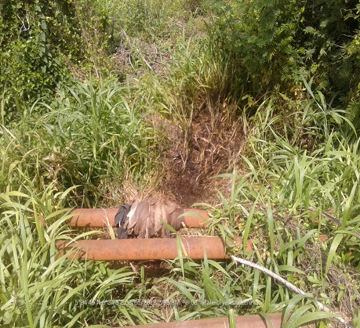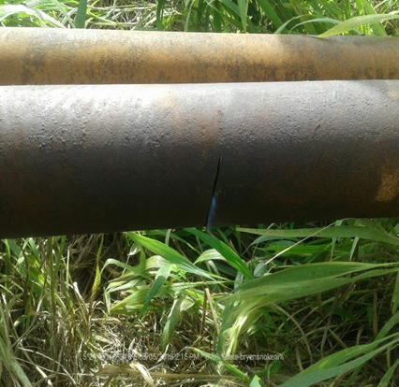
The flow line before repairs The 90mm hacksaw cut on the line

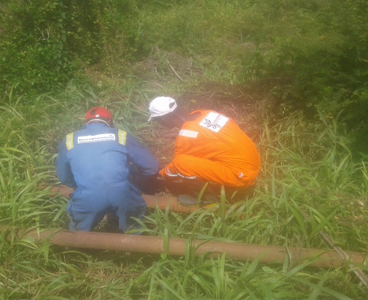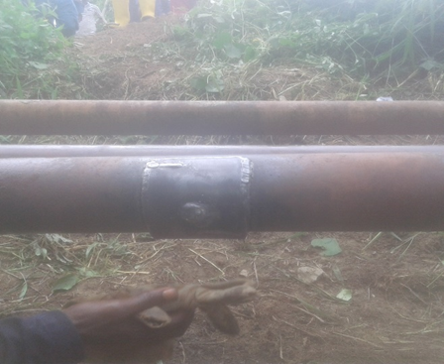
Staff of Fluiden Pentra Engineering LTD The flow line after repairs
working on the flow line

